**Week 14**

**TEAM MEETING**

***Cameron,*** *Diogo, Jose, Samuel, Yujui, Lio*

## Notes from meetings throughout the week

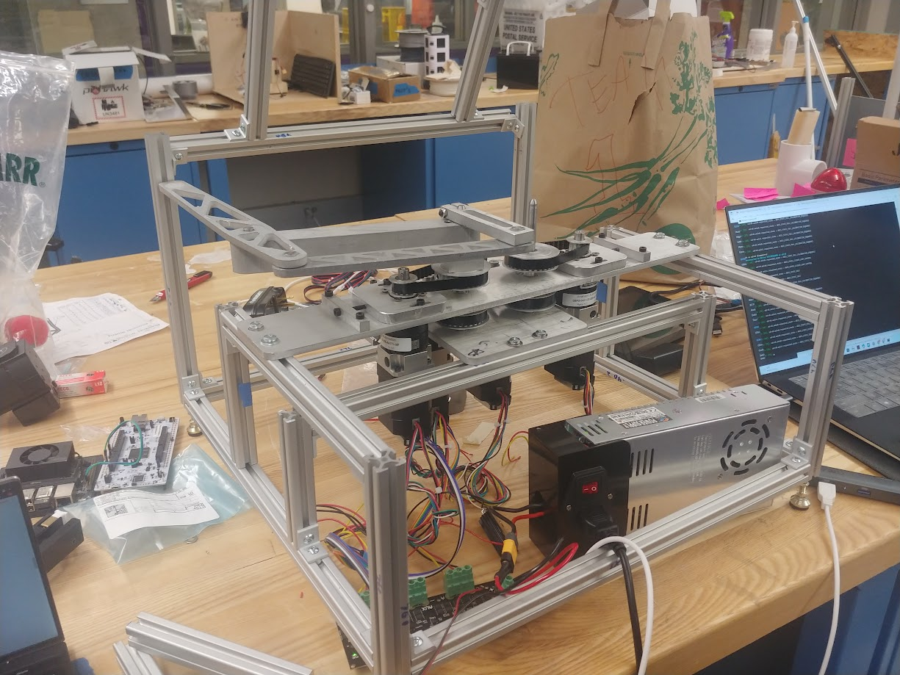

**Electronics**

Motor

* Assemble motor, gearbox, and encoder on the Alpha prototype and wait for the platform to assemble all the wire to Odrive and microcontroller.

Odrive

* Set the config of new odrive and test with the calibration.

Touchscreen

* Look up for the touch panel for multitouch and find other solution related to machine vision

**Software**

* Waiting for finished mechanism

**Magnet**

* Developed height variable magnet pucks to attest to the relationship between the normal and shear forces
* Got a new thicker magnet that seems promising in providing strong normal forces without adding too much friction
* Currently developing final prototypes for the alpha model

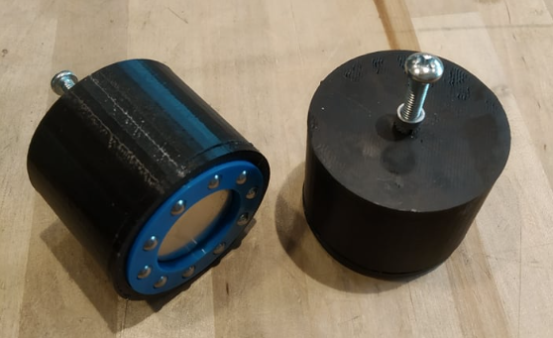

**Mechanical**

* Finished up final machined parts, assembled and cut full 8020 frame. The assembled mechanism is on the frame with 1 whole side complete. The other side is just waiting on 1 part that needs to be re-machined because a bearing fit was too loose.

# Meeting with Professors

## 

**Embedded**

**Electronics**

**Magnet**

**Manufacturing/Mechanical**

~~Almost all done, but more attention needs to be given to the squaring of the components. In need for a M4 tap.~~

**Magnets**

The new ‘tall’ magnet is very promising as it gives us 18N of normal force while still being decent in terms of feel when moving across the screen. Focus now on making a suitable user interface for it.

**Electronics**

We need to figure out a solution for the current screen as it only allows for 1 finger. We are considering separating the touch ability to a different component to be ordered, but so far no reliable providers. Priority on trying to find a screen with multi-touch screen, followed by an additional component that would come in the needed time frame. Last case scenario computer vision.

Given time, budget constraints and feasibility - computer vision is likely the way to go

**Embedded**

For the alpha let’s use mouse tracking and then decide future steps for beta